**Tiny Tools Rental Database 2.0 Installation Instructions**

# *Installation*

**Prerequisites**

To install our database, first ensure that Microsoft Access (64-bit), [Oracle Database (Version 19c Enterprise)](https://www.oracle.com/ca-en/database/technologies/oracle19c-windows-downloads.html), [Oracle SQL Developer (Including JDK)](https://www.oracle.com/database/sqldeveloper/technologies/download/), [OCDB Drivers](https://www.oracle.com/ca-en/database/technologies/instant-client/downloads.html) (and their [required prerequisites](https://support.microsoft.com/en-us/topic/the-latest-supported-visual-c-downloads-2647da03-1eea-4433-9aff-95f26a218cc0)) and the provided zipped folder package for the Tiny Tool rental database (**OracleToolRental.zip**) are properly installed on your device.

Ensure as well that you are able to connect to the Oracle database.

1. Open a command prompt as administrator
2. Run the command **sqlplus / as sysdba**
3. To view the name of your instance, you can run the command **show con_name**.
   * We will be using the instance name given from this command to create a new connection for the database in Oracle SQL Developer

**Installing the Oracle Database**

1. Open a command prompt as administrator (type in “cmd” in the search bar for windows, right-click it and press “Run as administrator”)
2. Ensure the directory that the command prompt is launched in the same directory that contains your download of the tiny tool rental database zipped folder file (**OracleToolRental.zip**)
   1. To change your directory in the command prompt, simply type:  
       **cd path/to/directory  
       ex. cd C:\Users\username\Downloads\OracleToolRental**
3. Run the command **“sqlplus / as sysdba”**
4. Run the SQL file provided in the package by running the command **@Database_Creation_Script.sql** (case sensitive). This script will create the database and the users and roles required for the application.
5. Exit out of sqlplus by typing the command **exit**
6. Open **ODBC Data Sources (64-bit)** (you can find it by typing in “ODBC” in the Windows search bar)
7. Under **System DSN**, click the **Add…** button
8. In the pop-up window, scroll down and select **Oracle in instantclient_19_26** and click **Finish**
9. In the Oracle ODBC Driver Configuration window, fill in:
   1. **tool_rental** (case sensitive) for the **Data Source Name**
   2. **toolRentalUser/userPassword** for the **User ID**
   3. The description is optional

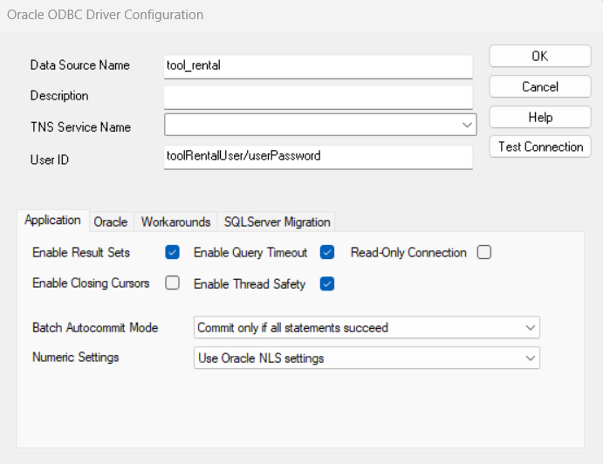

1. Click **Test Connection**. In the **Oracle ODBC Driver Connect** pop-up windows, fill in:
   1. **localhost:1521/YOURINSTANCENAME** as the **Service Name (orcl2355 in the picture below)**
      1. To check your instance name, refer to the command in step 3 under the Prerequisites section
   2. **toolRentalUser** as the **User Name**
   3. **userPassword** as the **Password**

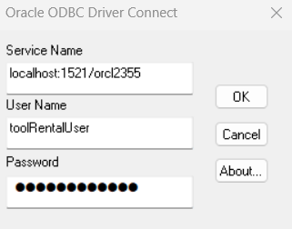

1. A window should pop up to tell you the connection was successful. Press OK to close the popup.
2. Press **OK** to add the connection.

When you open the front end Access file for the tool rental service application, you should now be connected to the Oracle backend.

**Install Access Front End**

1. Download the “**Tool Rental.accdb**” file that we have provided. Ensure permissions are allowed for the file by **right-clicking the file**, selecting **Properties** and then **checking** the **“Unblock”** option under **Security** in the **General** tab.
2. Open the “**Tool Rental.accdb**” file and select “**Enable Content**”.

You should now be able to access the front-end of the application.